Ex. No: 4 SQL inbuilt functions

**Date: 08/02/22**

**AIM:** To write SQL queries to execute different inbuilt functions.

Data base created for this exercise is:

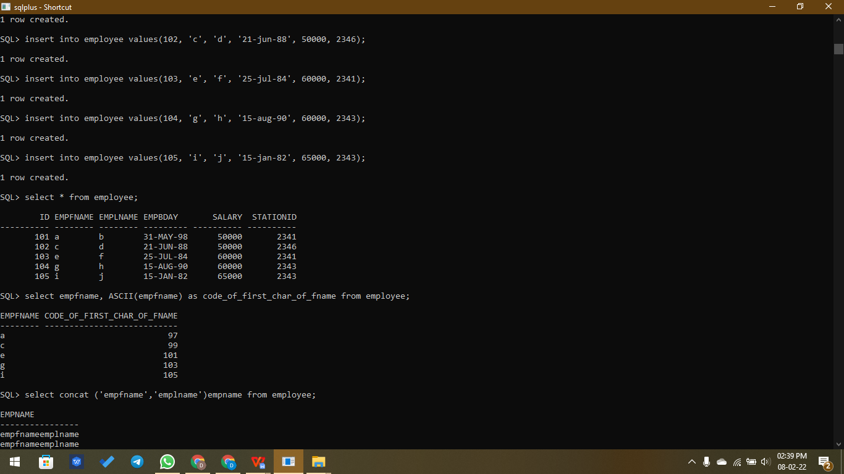

**Inbuilt functions:**

* **ASCII -** Used to find ASCII values for the first character of the string.

**Syntax,**

**select col_name, ASCII(col_name) from table_name;**

Example,

SQL> select empfname, ASCII(empfname) as code_of_first_char_of_fname from employee;

EMPFNAME CODE_OF_FIRST_CHAR_OF_FNAME

-------- ---------------------------

a 97

c 99

e 101

g 103

i 105

* **CONCAT -** Used to concat/merge two strings.

**Syntax,**

**select concat (col1,col2) from table_name;**

Example,

SQL> select concat (empfname,emplname)empname from employee;

EMPNAME

------------------------------------------------------------

ab

cd

ef

gh

Ij

* **UPPER -** Used to make all characters in the string to upper case.

**Syntax,**

**select upper(col_name) from table_name;**

Example,

SQL> select upper(empfname) from employee;

UPPER(EMPFNAME)

------------------------------

A

C

E

G

I

* **COUNT -** Used to count records in the table.

**Syntax,**

**select count(col_name) from table_name;**

Example,

SQL> select count(id) from employee;

COUNT(ID)

----------

5

* **LTRIM -** Used to trim left spaces from a string.

**Syntax,**

**select ltrim(col_name) from table_name;**

Example,

SQL> select ltrim(empfname) from employee;

LTRIM(EMPFNAME)

------------------------------

a

c

e

g

i

K

* **REPLACE -** Used to replace characters in a string.

**Syntax,**

**select replace(col_name,'original_substring','new_substring') from table_name;**

Example,

SQL> select replace(empfname,'m','x') from employee where id = 107;

REPLACE(EMPFNAME,'M','X')

------------------------------

xnx

* **ADD_MONTHS -** Used to get next or previous months from a date.

**Syntax,**

**SELECT col_name, add_months(col_name,number_to_add_to_month) FROM table_name;**

Example,

SQL> select empbday, add_months(empbday,1) from employee;

EMPBDAY ADD_MONTH

--------- ---------

31-MAY-98 30-JUN-98

21-JUN-88 21-JUL-88

25-JUL-84 25-AUG-84

15-AUG-90 15-SEP-90

15-JAN-82 15-FEB-82

17-FEB-84 17-MAR-84

17-FEB-84 17-MAR-84

7 rows selected.

* **EXTRACT -** Used to get day/month/year from a date.

**Syntax,**

**SELECT col_name, extract(col_name) FROM table_name;**

Example,

SQL> select empbday, extract(year from empbday)year from employee;

EMPBDAY YEAR

--------- ----------

31-MAY-98 1998

21-JUN-88 1988

25-JUL-84 1984

15-AUG-90 1990

15-JAN-82 1982

17-FEB-84 1984

17-FEB-84 1984

7 rows selected.

SQL> create table employee(id int, empfname varchar(30), emplname varchar(30), empbday date, salary int, stationid int);

Table created.

SQL> insert into employee values(101, 'a', 'b', '31-may-98', 50000, 2341);

1 row created.

SQL> insert into employee values(102, 'c', 'd', '21-jun-88', 50000, 2346);

1 row created.

SQL> insert into employee values(103, 'e', 'f', '25-jul-84', 60000, 2341);

1 row created.

SQL> insert into employee values(104, 'g', 'h', '15-aug-90', 60000, 2343);

1 row created.

SQL> insert into employee values(105, 'i', 'j', '15-jan-82', 65000, 2343);

1 row created.

SQL> select * from employee;

ID EMPFNAME EMPLNAME EMPBDAY SALARY STATIONID

---------- -------- -------- --------- ---------- ----------

101 a b 31-MAY-98 50000 2341

102 c d 21-JUN-88 50000 2346

103 e f 25-JUL-84 60000 2341

104 g h 15-AUG-90 60000 2343

105 i j 15-JAN-82 65000 2343

SQL> select empfname, ASCII(empfname) as code_of_first_char_of_fname from employee;

EMPFNAME CODE_OF_FIRST_CHAR_OF_FNAME

-------- ---------------------------

a 97

c 99

e 101

g 103

i 105

SQL> select concat (empfname,emplname)empname from employee;

EMPNAME

------------------------------------------------------------

ab

cd

ef

gh

ij

SQL> select upper(empfname) from employee;

UPPER(EMPFNAME)

------------------------------

A

C

E

G

I

SQL> select count(id) from employee;

COUNT(ID)

----------

5

SQL> insert into employee values(106, ' k', 'l ', '17-feb-84', 55000, 2343);

1 row created.

SQL> select * from employee;

ID EMPFNAME EMPLNAME EMPBDAY SALARY STATIONID

---------- -------- -------- --------- ---------- ----------

101 a b 31-MAY-98 50000 2341

102 c d 21-JUN-88 50000 2346

103 e f 25-JUL-84 60000 2341

104 g h 15-AUG-90 60000 2343

105 i j 15-JAN-82 65000 2343

106 k l 17-FEB-84 55000 2343

6 rows selected.

SQL> select ltrim(empfname) from employee;

LTRIM(EMPFNAME)

------------------------------

a

c

e

g

i

k

6 rows selected.

SQL> insert into employee values(107, 'mnm', 'opp', '17-feb-84', 55000, 2343);

1 row created.

SQL> select replace(empfname,'m','x') from employee where id = 107;

REPLACE(EMPFNAME,'M','X')

------------------------------

xnx

SQL> select empbday, add_months(empbday,1) from employee;

EMPBDAY ADD_MONTH

--------- ---------

31-MAY-98 30-JUN-98

21-JUN-88 21-JUL-88

25-JUL-84 25-AUG-84

15-AUG-90 15-SEP-90

15-JAN-82 15-FEB-82

17-FEB-84 17-MAR-84

17-FEB-84 17-MAR-84

7 rows selected.

SQL> select empbday, extract(year from empbday)year from employee;

EMPBDAY YEAR

--------- ----------

31-MAY-98 1998

21-JUN-88 1988

25-JUL-84 1984

15-AUG-90 1990

15-JAN-82 1982

17-FEB-84 1984

17-FEB-84 1984

7 rows selected.

SQL> spool off

**Result:**

Thus the inbuilt functions are used to modify or manipulate data records present in the employee table.